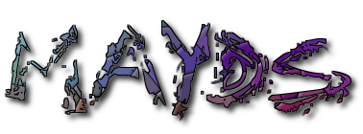

Mid Argyll Youth Development Services

50a Union Street

Lochgilphead

Argyll

PA31 8JS

Phone: 01546603231

Providing Information and Accessible Youth Friendly Services

Mid Argyll Youth Development Services

Registered Charity: SC022931

**MID ARGYLL YOUTH DEVELOPMENT SERVICES**

**CONSENT FORM**

**This form should be completed by a parent/guardian before your child can participate in the event detailed below. One form should be completed for each child/young person.**

|  |
| --- |
|  |

|  |
| --- |
| **Details of event:** |
| **Venue:** |
| **Date:** |
| **Time:** |

**I agree to my son/daughter taking part in the above mentioned event.**

|  |
| --- |
| **Name of Child:** |
| **Address:**  **Postcode:** |
| **Date of Birth:** |
| **Parent(s)/Guardian name:** |
| **Telephone No: Work:** |
| **Mobile No:** |

**MEDICAL INFORMATION**

|  |
| --- |
| **Does your son/daughter suffer from any conditions requiring special medical treatment, including medication? If YES please give details below.**  **Is your son/daughter allergic to any medication? If YES please give details below.** |

|  |
| --- |
| **Does your son/daughter have any special dietary requirements?** |

|  |
| --- |
| **Please state date of last tetanus injection (if known)** |

|  |
| --- |
| **NAME OF DOCTOR** |
| **DOCTORS ADDRESS**  **TELEPHONE NO-:** |

**We would appreciate an alternative contact name and details (in case we are unable to contact you)**

|  |
| --- |
| **Name:** |
| **Relationship to child**  **(aunt, neighbour etc):** |
| **Address:**  **Postcode:** |
| **Telephone No: Work:** |
| **Mobile:** |

**ADDITIONAL INFORMATION**

**Can your child swim at least 25 metres?**

**YES NO**

**I give permission for to take part in this residential program arranged by the youth project.**

**Signed: Date:**

|  |  |
| --- | --- |
| **In an emergency and/ or if I am not contactable, I am willing for my child to receive necessary hospital or dental treatment including an anaesthetic.**  **YES NO (Please tick)** | **Date:**  **Signature:**  **(parent or adult with parental responsibility)** |

|  |
| --- |
| **FOR YOUTH GROUP USE:**  **Date form received: Membership No:** |

**Data Protection :**

The information you provide in this form will be used solely for dealing with your child/children as a member of The Mid Argyll Youth Development Services (MAYDS).

MAYDS has a Data Privacy Policy which can be found on our webpage and in the main office. Your data will be stored and used in accordance with this Policy.

MAYDS may arrange for photographs or videos to be taken of MAYDS activities and published on our website, annual review &/or social media channels to promote MAYDS.

PARENTAL/GUARDIAN/AGENCY CONSENT (for children under 18)

If you consent to the use of your child’s image being used for the purposes above please tick here.

If you/ the individuals listed above later wish to withdraw consent, please contact MAYDS main office on 01546 603231.

By agreeing to your images being used, you agree to assign any copyright or any other right of ownership of these images to MAYDS.

**Signature**…………………………………………………………….**Date**……………………………

If you have any queries, questions or comments on the information above please contact MAYDS main office

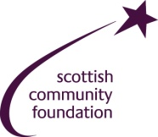RT.jpg 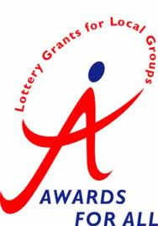

MAYDS Ltd Company number: 396832